**Footprinting and Reconnaissance**

**By,**

**K.Divya**

**Information gathering in WHOIS**

Domain Information

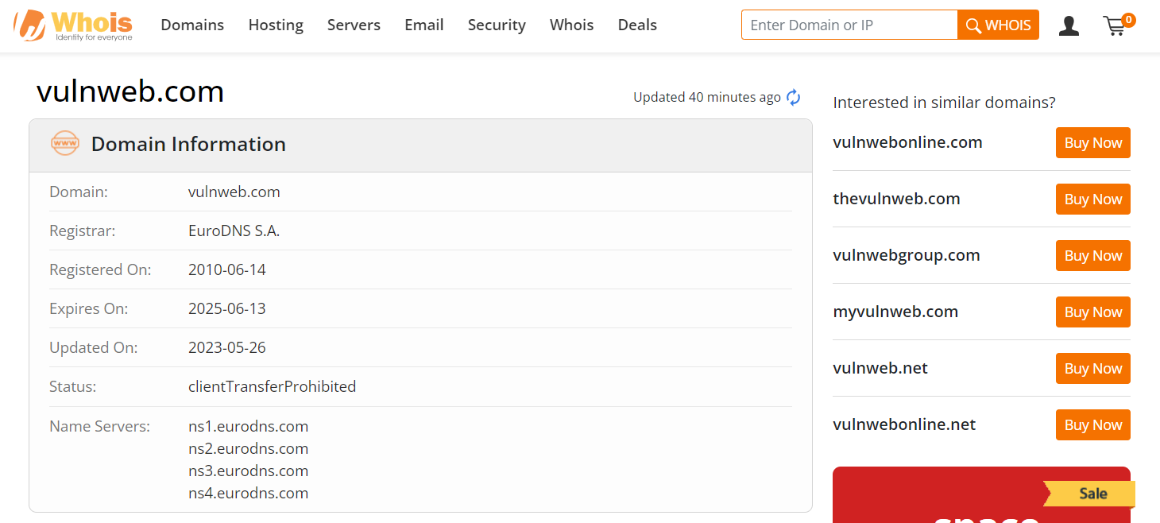

Registrant Contact

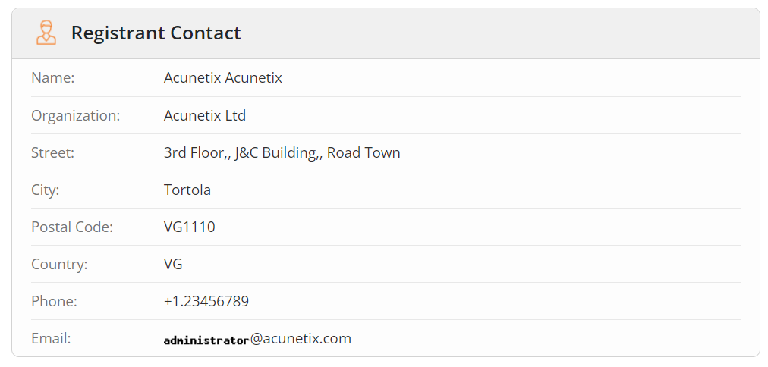

Administrative Contact

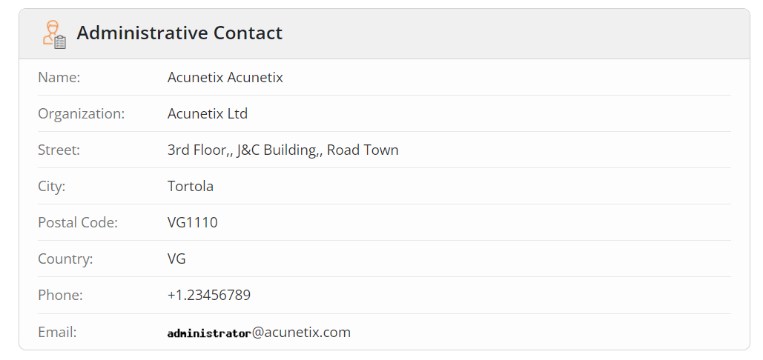

Technical Contact

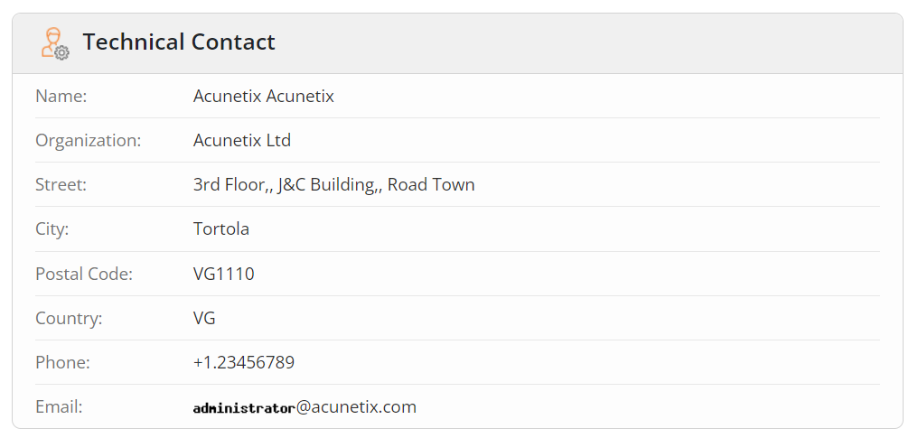

**Raw Whois Data**

Domain Name: vulnweb.com

Registry Domain ID: D16000066-COM

Registrar WHOIS Server: whois.eurodns.com

Registrar URL: http://www.eurodns.com

Updated Date: 2023-05-26T10:04:20Z

Creation Date: 2010-06-14T00:00:00Z

Registrar Registration Expiration Date: 2025-06-13T00:00:00Z

Registrar: Eurodns S.A.

Registrar IANA ID: 1052

Registrar Abuse Contact Email: email@eurodns.com

Registrar Abuse Contact Phone: +352.27220150

Domain Status: clientTransferProhibited http://www.icann.org/epp#clientTransferProhibited

Registry Registrant ID:

Registrant Name: Acunetix Acunetix

Registrant Organization: Acunetix Ltd

Registrant Street: 3rd Floor,, J&C Building,, Road Town

Registrant City: Tortola

Registrant State/Province:

Registrant Postal Code: VG1110

Registrant Country: VG

Registrant Phone: +1.23456789

Registrant Fax:

Registrant Email: email@acunetix.com

Registry Admin ID:

Admin Name: Acunetix Acunetix

Admin Organization: Acunetix Ltd

Admin Street: 3rd Floor,, J&C Building,, Road Town

Admin City: Tortola

Admin State/Province:

Admin Postal Code: VG1110

Admin Country: VG

Admin Phone: +1.23456789

Admin Fax:

Admin Email: email@acunetix.com

Registry Tech ID:

Tech Name: Acunetix Acunetix

Tech Organization: Acunetix Ltd

Tech Street: 3rd Floor,, J&C Building,, Road Town

Tech City: Tortola

Tech State/Province:

Tech Postal Code: VG1110

Tech Country: VG

Tech Phone: +1.23456789

Tech Fax:

Tech Email: email@acunetix.com

Name Server: ns1.eurodns.com

Name Server: ns2.eurodns.com

Name Server: ns3.eurodns.com

Name Server: ns4.eurodns.com

DNSSEC: unsigned

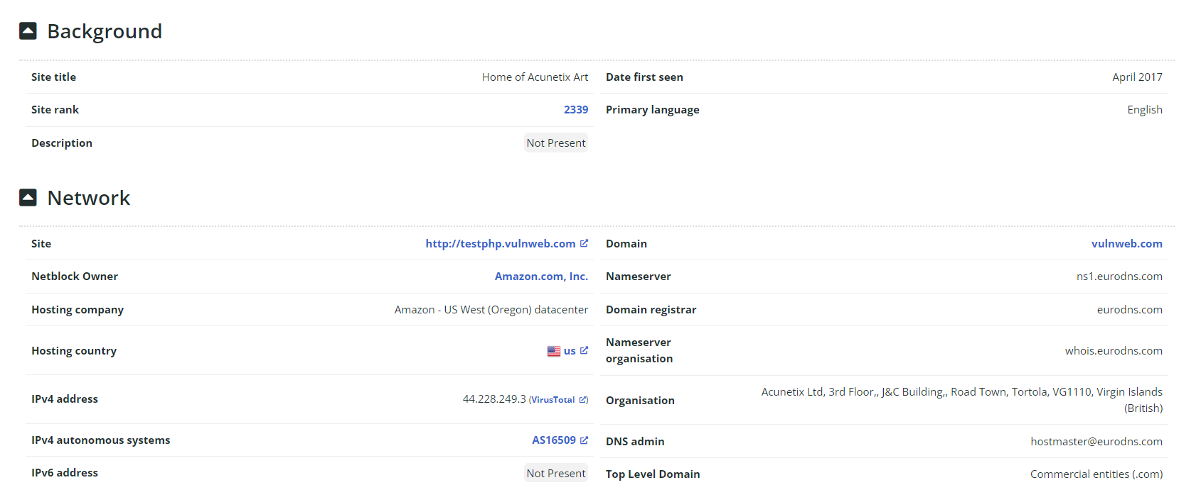

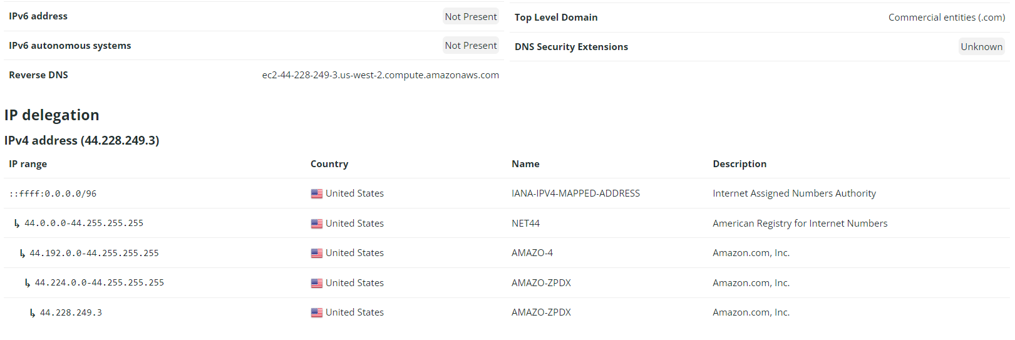

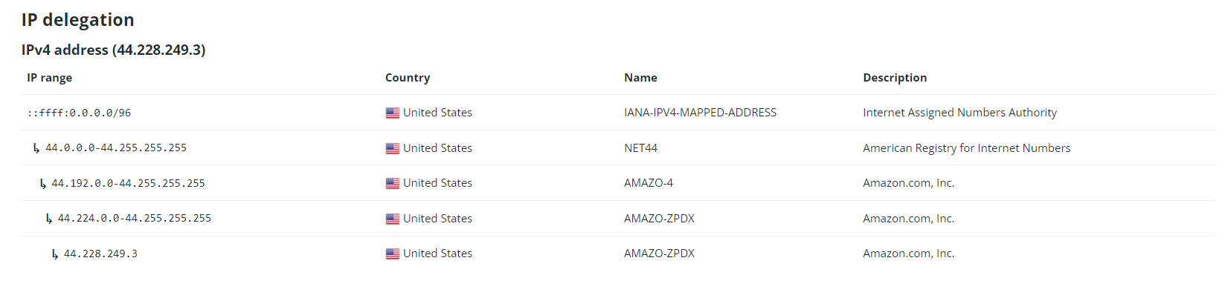

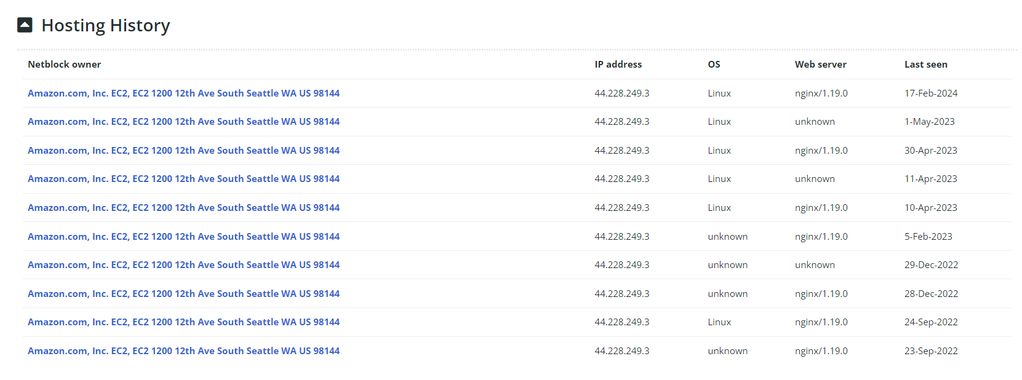

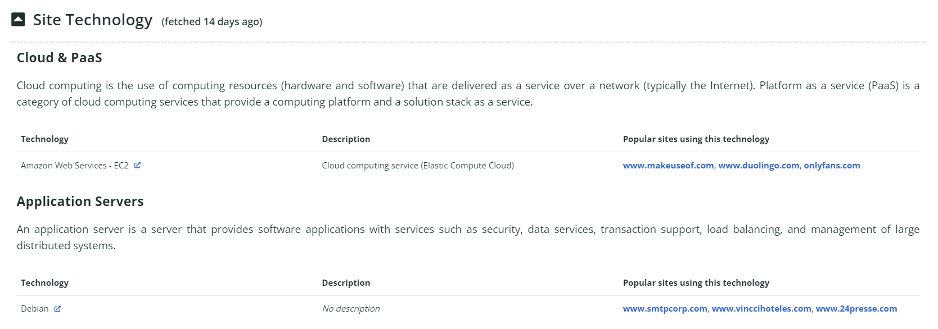

**Using Nmap Tool**

Intense Scan

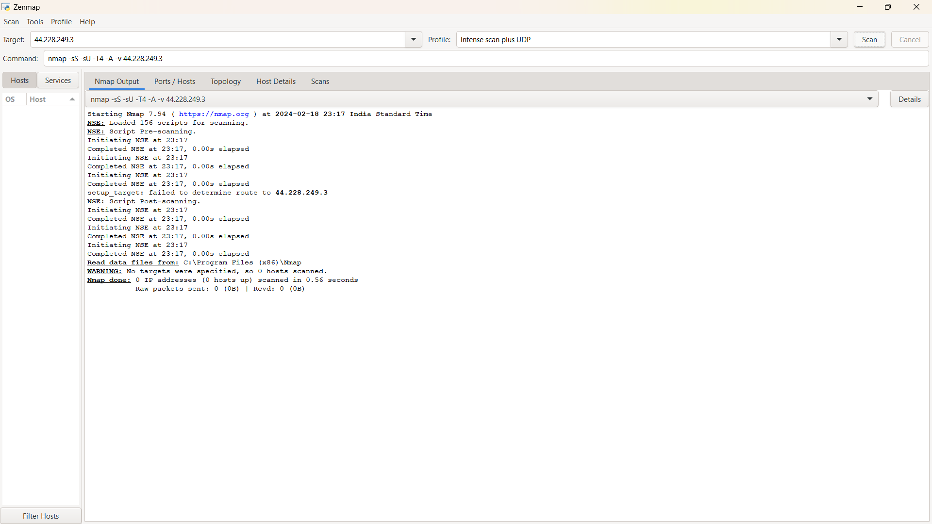

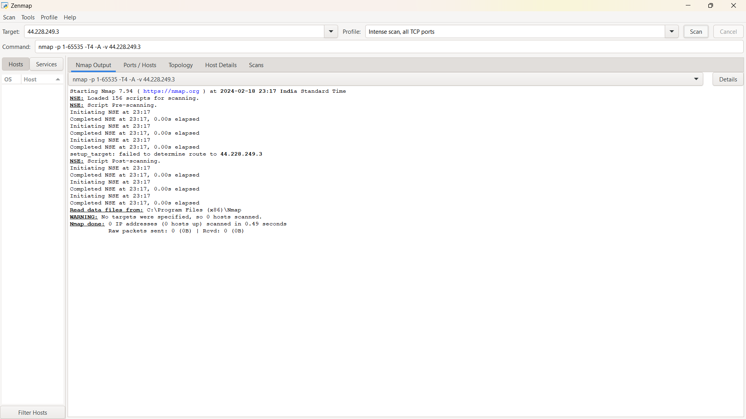

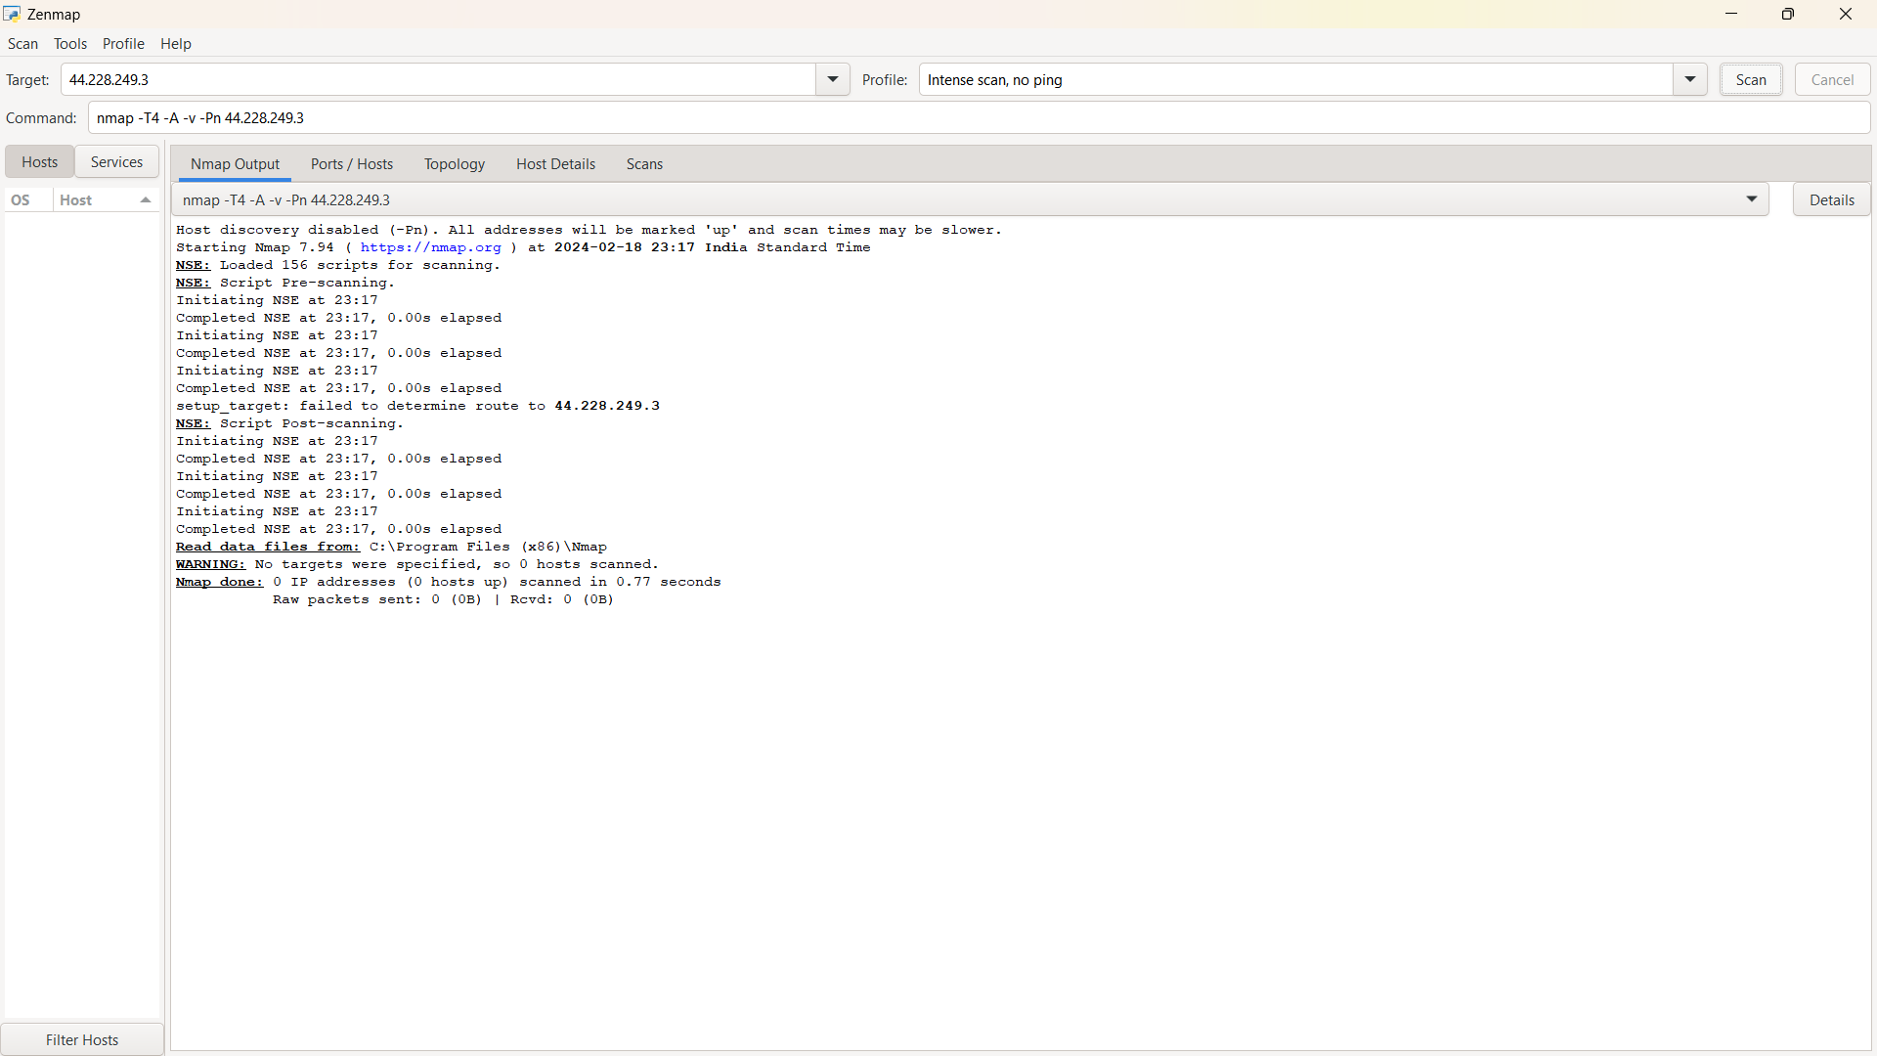

**In Kali linux Nmap**

